Freedom of Information Act 1992
Small Business Development Corporation
Information statement
January 2024

Table of contents
Foreword 3
About the SBDC 3
Agency structure 3
Access to information 5
FOI applications 5
Amendment of personal information 6
Freedom of Information charges 7
Notice of decision 7
Refusal of access and internal reviews 7
External review 8

Foreword
This statement may assist potential applicants in directing their Freedom of Information (FOI) application to the correct agency. If the Small Business Development Corporation’s (SBDC) information statement does not list the kind of documents the applicant is seeking, they may
need to pursue their enquiries with another agency.

About the SBDC
Mission
Deliver and facilitate relevant, practical support to small business and advocate on their behalf.
Legislation administered
The SBDC is an independent statutory authority, established in 1984 under the Small Business Development Corporation Act 1983.

Agency structure
SBDC board
The SBDC is governed by an independent board, drawn from the private sector under the auspices of the Small Business Development Corporation Act 1983.
Small Business Commissioner
The SBDC’s operational functions are overseen by the Chief Executive Officer, who is also Western Australia’s Small Business Commissioner. This position reports to the board.

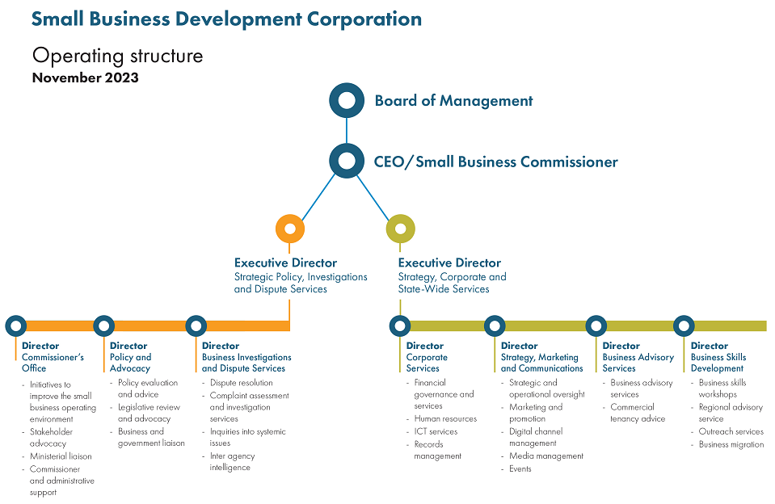

Freedom of Information (FOI)
Documents available outside FOI
The SBDC website has a number of publications and other information available at: www.smallbusiness.wa.gov.au
For information not available on the website, please email infocentre@smallbusiness.wa.gov.au
Agency documents
The SBDC’s corporate documents are predominantly held in electronic formats, however some hard copy information is stored. These corporate documents are recorded in the Corporation’s recordkeeping system.
The broad category of information available, but not necessarily accessible, under the Freedom of Information Act 1992 includes:
- board;
- administration;
- technology and communication;
- policy and procedure;
- advocacy;
- submissions;
- records management;
- accounting;
- people services;
- investigations;
- grants;
- business migration; and
- regional service provision.

Access to information
It is the aim of the SBDC to make information available promptly and with minimal costs, if any.
The Freedom of Information Act 1992 (the Act) gives members of the public the right to access documents held by the SBDC. It offers a means to request amendments of personal information which is inaccurate, incomplete, out-of-date or misleading.
To safeguard personal information, applicants applying for their own personal information are required to provide a copy of photographic identification such as a driver’s licence or passport.

FOI applications
Section 12(1) of the Act sets out the criteria required for applications to access information.
Access applications must:
- be in writing;
- include enough information so that the documents requested can be identified;
- list an Australian address to which notices can be sent; and
- be lodged at the agency with any application fee payable.
Applications can be submitted online, including any relevant payment, through the SBDC website by following this link. If the application is in regards to personal information, payment is not required.
Alternatively, any applications should be addressed to the Information Coordinator in writing. After an application is received, the applicant will be forwarded information regarding relevant payment, to be made before the request is processed.
Applications will be acknowledged in writing and the applicant will be notified of the decision within 45 calendar days, or sooner where practicable.
Office location
SBDC Reception
Level 2
140 William Street
Perth WA 6000
Office hours
Monday – Friday
8.30am to 4.30pm
Postal address
GPO BOX C111
Perth WA 6001
Email
infocentre@smallbusiness.wa.gov.au
Website
www.smallbusiness.wa.gov.au
Phone
(08) 6552 3300

Amendment of personal information
Members of the public who believe personal information held by the SBDC is inaccurate may request access to personal records in writing. They may then request that information about them that is inaccurate, incomplete, out of date or misleading, be corrected. The request must articulate the details that require updating and the reason why.

Freedom of Information charges
A scale of fees and charges is set under the FOI Act Regulations. Apart from the application fee for non-personal information, all charges are discretionary.
Type of fee
Applicant’s personal information | No fee
Application fee (non-personal information) | $30.00

Type of charge
(Details the maximum charge for time dealing with applications)
Per hour, or pro rata | $30.00
Access time supervised by staff (per hour, or pro rata) | $30.00
Photocopying staff time (per hour, or pro rata) | $30.00
Per photocopy | 20 cents
Transcribing from tape, film or computer (per hour or pro rata) | $30.00
Duplicating a tape, film or computer information | Actual cost
Delivery, packaging and postage | Actual cost

Deposits
Advance deposit may be required of the estimated charges | 25% of total estimated charges
Further advance deposit may be required to meet the charges for dealing with the application | 75% of total estimated charges

Notice of decision
Within 45 days, or sooner where practicable, the applicant will be provided with a notice of decision that will include:
- the date the decision was made;
- the name and the designation of the officer who made the decision;
- whether the document is an exempt document, the reasons for classifying the
matter exempt; or the fact that access is given to an edited document; and
- information on the rights of review and the procedures to be followed to exercise
those rights.

Refusal of access and internal reviews
Applicants who are dissatisfied with a decision of the agency are entitled to ask for an internal review by the SBDC. Applications should be made in writing within 30 days of receiving the notice of decision.
Applicants should be notified of the outcome of the review within 15 days.
If the applicant disagrees with the result the applicant can apply to the Information Commissioner for external review.

External review
If you are not satisfied with the internal review decision, you have the right to lodge an application for external review with the Information Commissioner within 60 days of receiving the notice of decision.
An application for external review to the Information Commissioner must:
- be in writing;
- have attached a copy of the decision; and
- give an Australian address.
There is no charge for lodging an application for external review with the Information Commissioner’s office.
External review applications are to be sent to:
Office of the Information Commissioner
Albert Facey House
496 Wellington Street
Perth WA 6000
Further detail about Freedom of Information is available at the Office of the Information Commissioner website.

